F1 (one family) KOST=11/12/13: (S11-S33)
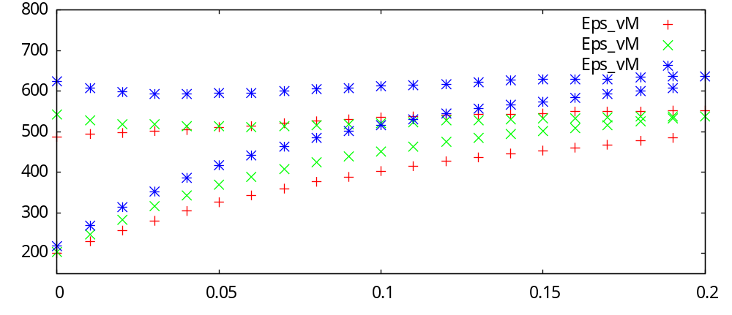
F2 (two families) KOST=11/12/13: (S11-S33)
